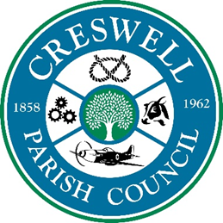
CRESWELL PARISH COUNCIL
ANNUAL PARISH MEETING

6th September 2021 at 7pm to 7.30pm

To: All Parish Councillors, local residents and press; are invited to the
Annual Parish Meeting to be held at Tillington Manor Primary School, Young Avenue, Holmcroft ST16 1PW

AGENDA
1 | Apologies
2 | To receive the Chairman’s Annual Report
3 | To receive reports from County/District Councillors (if available)
4 | To consider proposals of which written notice has been sent to the Clerk by any elector before the meeting
5 | Public Forum  Opportunity for members of the public to raise issues with the Parish Council.

Nikola Evans - Clerk
clerk@doxeyparishcouncil.gov.uk

