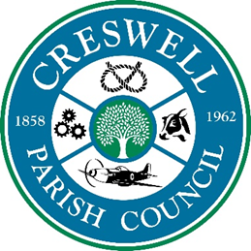
CRESWELL PARISH COUNCIL
ANNUAL PUBLIC MEETING

9th May 2022 at 7pm to 7.30pm

To: All Parish Councillors, local residents and press; are invited to the
Annual Public Meeting to be held at Stafford North End Community Centre, Holmcroft Road, Stafford ST16 1JG

AGENDA
1 | Apologies
2 | Minutes of last Meeting – 6th September 2021
3 | To receive the Chairman’s Annual Report
4 | To receive reports from County/District Councillors (if available)
5 | To consider proposals of which written notice has been sent to the Clerk by any elector before the meeting.
6 | Public Forum  Opportunity for members of the public to raise issues with the Parish Council. The parish council would encourage residents to coordinate any questions to maximise your time.

Nikola Evans - Clerk
clerk@creswellparishcouncil.co.uk

