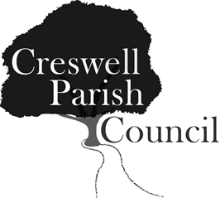
Creswell Parish Council
55th Annual Public Meeting
Tillington Manor Primary School Assembly Hall, Young Avenue, Holmcroft
On Monday 3rd April 2017 at 7.00pm

Tea and coffee will be provided

All attendees are requested to fill in the registration sheet

AGENDA

1 Welcome by the Chairman of Creswell Parish Council – Councillor Maria Redfern

2 Approval of Minutes of the 54th Annual Public Meeting - these will not be read out but copies are available in advance and on the night.

3 Presentation by Speedwatch Staffordshire Co-ordinator Michelle Shaker

4 Reports by Local Borough and County Councillors

5 Statement (circulated) of the Parish Councils main activities over the past 12 months. The full minutes can be found on the Parish Council website www.creswellparishcouncil.co.uk .

Annual Report of the Parish Council by the Chairman

6 Statement on the Parish Council accounts for Year ending 31st March 2017 by the Clerk to the Parish Council

7 Planning report

8 Public Forum: Questions to Parish Councillors from the public

9 Close and return of attendance register

