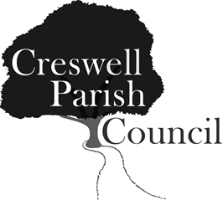
Creswell Parish Council
Annual Public Meeting
Stafford North End Centre, Holmcroft Road, Stafford
On Tuesday 21st May 2019 at 7.00pm

Tea and coffee will be provided

AGENDA

1 Welcome by the Chairman of Creswell Parish Council – Councillor Maria Redfern

2 Approval of Minutes of the 2018 Annual Public Meeting - these will not be read out but copies are available in advance and on the night.

3 Reports by Local Borough and County Councillors

4 Public Forum: Opportunity for members of the public to raise issues with the Parish Council.

5 Annual Report of the Parish Council by the Chairman

6 Close of meeting

