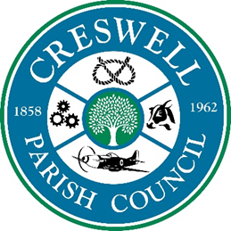
Clerk: Mrs Nikola Evans
www.creswellparishcouncil.co.uk
Email: Clerk@creswell-pcv.gov.uk Tel: 07971226170

Paish Councillors are hereby summoned to attend the parish council meeting Held at Stafford North End Community Centre
Holmcroft Road, Stafford ST16 1JG
Monday 7th July 2025 from 7:30pm

The Public and Press are cordially invited to be present, but please note that you may be excluded from any item the council decide should be treated as confidential.
Issued 30.07.25 Mrs. Nikola Evans (Clerk/RFO) Agenda
1 | Declaration of Interest on agenda items
2 | Apologies
3 | Minutes of last Meeting – 2nd June 2025
Meeting opened to the Public.
5 | To receive a report from Stafford Borough Council
6 | To receive a report from Stafford County Council
7 | Public Participation – Members of the public are invited to address the Council on any issue over which it has power for up to 5 minutes each, with the item lasting a maximum of 20 minutes.
Meeting closed to the public
8 | Matters arising from previous minutes
9 | Planning - All documents are available to view at www.staffordbc.gov.uk/planning-public-access
10 | Finance  - Approval of Payments  - Approve Budget summary  - Approve Bank Reconciliation
11 | To discuss any new highways, footpaths or village maintenance issues.
12 | To consider quotation for a solar/wind powered AED at Marston Grange.
13 | Confidential item - Staffing matters
14 | Councillors Reports - Cllrs are invited to give reports on the parish  - Upcoming events
15 | Future meeting dates  - 1st September 2025 @ Stafford North End Community Centre – from 7.30pm  - Future meetings:  - 3rd November 2025  Next agenda items:
16 | Meeting Close

