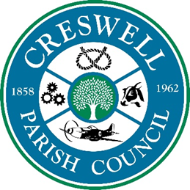
CRESWELL PARISH COUNCIL
ANNUAL PUBLIC MEETING

7th April 2025 at 7.00pm

To: All Parish Councillors, local residents and press; are invited to the
Annual Public Meeting to be held at Stafford North End Community Centre, Holmcroft Road, Stafford ST16 1JG

AGENDA
1 | Apologies
2 | Minutes of last Meeting – 17th June 2024
3 | To receive the Chairman’s Annual Report
4 | Public Forum  Opportunity for members of the public to raise issues with the Parish Council.

Nikola Evans - Clerk
clerk@creswellparishcouncil.co.uk

