
Minutes
Minutes for the parish council meeting held on Monday 1st December 2025 from 7.30pm. At Stafford North End Community Centre, Holmcroft Road, Stafford ST16 1JG

ATTENDANCE
Cllr M Harford  Chairperson | Cllr T Glover  Vice Chairperson | Cllr C Hawkridge
Cllr G Ellis  (Joined from item 5) | Clerk – Nikola Evans | Cllr J Rose – SBC & SCC
MOP - 0

1 |  | Declaration of Interest on agenda items and dispensations granted
 |  | None received
2 |  | Apologies
 |  | None, all members attended
3 |  | Minutes of last Meeting – 1st December 2025
 |  | Approved as a true record by all that attended
4 |  | To consider candidate for co-option
 |  | All in favour of co-opting George Ellis as a new member of Creswell Parish Council.
5 |  | Signing of the declaration of acceptance of office
 |  | Completed
Meeting opened to the Public
6 | To receive a report from Stafford Borough Council
 | None
7 | To receive a report from Stafford County Council
 | None
8 | Public Participation – Members of the public are invited to address the Council on any issue over which it has power for up to 5 minutes each, with the item lasting a maximum of 20 minutes.
 | None
Meeting closed to the public
9 | Planning - All documents are available to view at www.staffordbc.gov.uk/planning-public-access
 | None
10 | Finance
10.1 | Approval of Payments
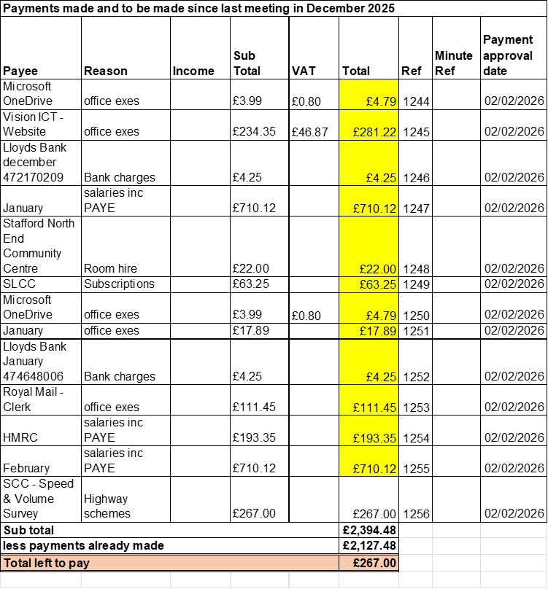

APPROVED
10.2 | Approve Budget summary
 | APPROVED
10.3 | Approve Bank Reconciliation
 | APPROVED
10.4 | To consider purchasing a Tommy memorial bench to replace the damaged bench on the corner of Wilkes Wood.
 | APPROVED, clerk to action
10.5 | To approve another 4k to elections earmarked funds, totalling £10k for the potential 2027 elections should parish council have to fund them.
 | APPROVED
11 | To adopt the following policies for new AGAR Assertion 10 (Digital & Data Compliance) requirements  - Data Protection Policy  - IT & Digital Communications Policy  - Social media Policy  - ICO Publication Scheme & Guide to information
 | All policies in item 11 were APPROVED, no changes made. Clerk to upload onto website
12 | To consider arrangements for Perrin Memorial / Harry Kerr Day.
 | Date agreed, Saturday 4th July 2026, from 11am. Clerk to invite members from RAFA, Staffordshire Royal Engineers, two cadets (names and addresses to be supplied by Cllrs MH & TG to clerk) and MOP. Clerk to organise event, purchase two wreaths and new flags from Flag makers @ £284.83 inc. VAT. for use on special occasions.
13 | To discuss any new highways, footpaths or village maintenance issues.  - Damaged Road signs
 | Approval has been given to the parish council to fund new road signs, clerk to action.
14 | Councillors/Clerk Reports – For information only  - Speed & Volume Survey results
An automatic radar-based speed survey was carried out from 21.11.2025 to 28.11.2025. on A5013, Creswell Grove/Eccleshall Road.
Headline figures
- Average (mean) speed northbound - 29.4 mph
- Average (mean) speed southbound - 29.1 mph
- 85th percentile speed northbound - 34.2 mph
- 85th percentile speed southbound - 33.6 mph
Note: 85th percentile speed is the speed that 85% of the vehicles measured travelled at or slower, e.g. 50 mph – 85% of vehicles measured travelled at 50 mph or less. This is a recognised measure used by the Police when considering enforcement and local highway authorities for some aspects of highway design.
Comments
The data captured shows the 85th percentile speeds is compliant of the 30mph speed limit, with only a small proportion of vehicles exceeding, suggesting no immediate safety concern. The Police enforcement threshold is 10% + 2mph.
15 | Next meeting date  - 4th May 2026 – Annual Public Meeting, from 18:30 pm  - 4th May 2026 – Annual Parish Council Meeting from 19:30 pm
 | APPROVED
16 | Future meetings:  - 6th July 2026 from 19:30pm  - 5th October 2026 from 19:30pm  - 11th January 2027, from 19:30pm
 | APPROVED
17 | Meeting closed
 | 20:45

For the purpose of this meeting, SCC refers to Staffordshire County Council, SBC refers to Stafford Borough Council and MOP refers to Members of the public.

