**Finance Report 01.09.25**

Item 9 Finance

1. Approval of Payments



1. Approve Budget summary – page 2
2. Approve Bank Reconciliation – page 3



**Bank reconciliation as at 31.08.25**

Balance as per statement £1575.34

Less payments to be made £710.12

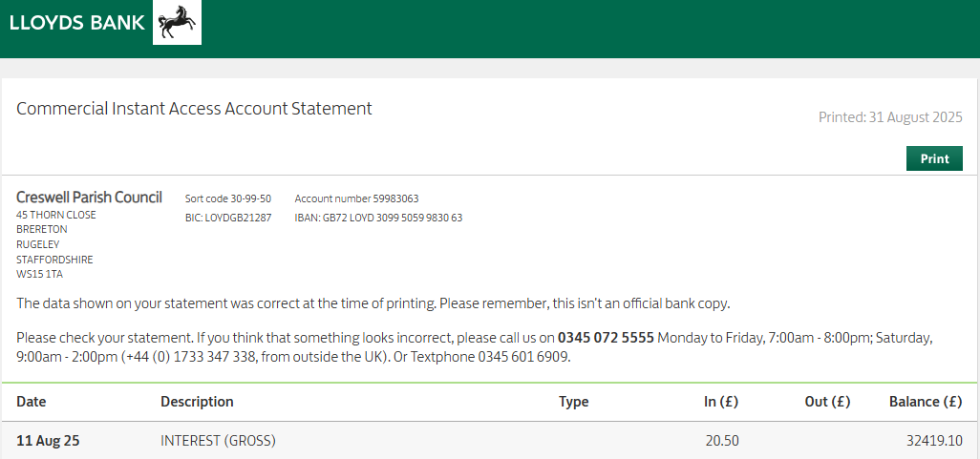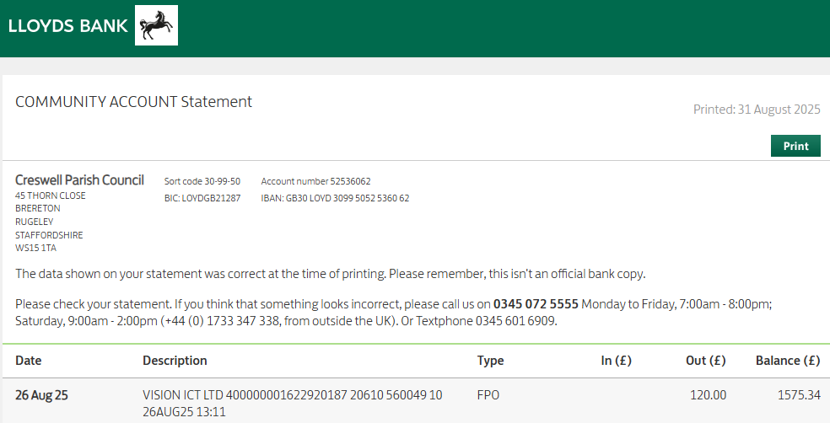Balance as per cash book £865.22