Finance Report – 2nd February 2026
Item 10 – Finance
10.1 Payment Approval
10.2 Approve budget summary – page 2
10.3 Approve Bank reconciliation – page 3

Bank reconciliation as at 2nd February 2026
Balance as per statement £2590.46
Less payments to be made £267.00
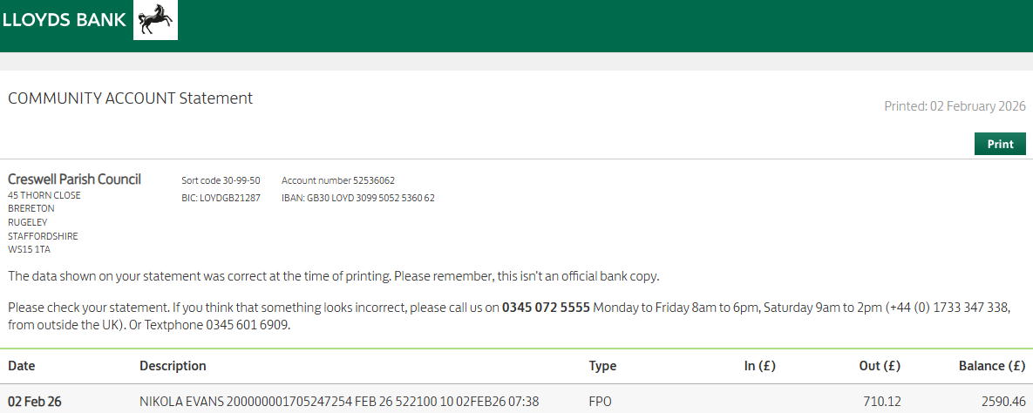
Balance as per cashbook £2323.46
