- Many residents in Creswell reported that they have not received any communication from highways relating to the work, can I confirm if all of Creswell Grove was meant to receive letters/communications?
The attached scheme start letter was sent to the addresses shown on the images below:
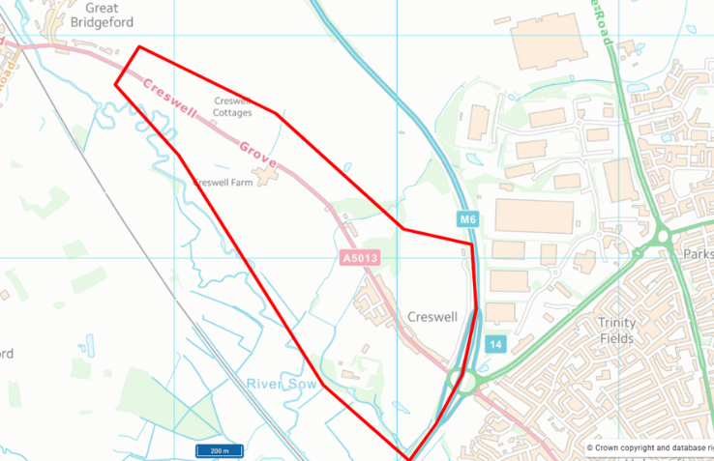
160 addressed west of M6 J14.
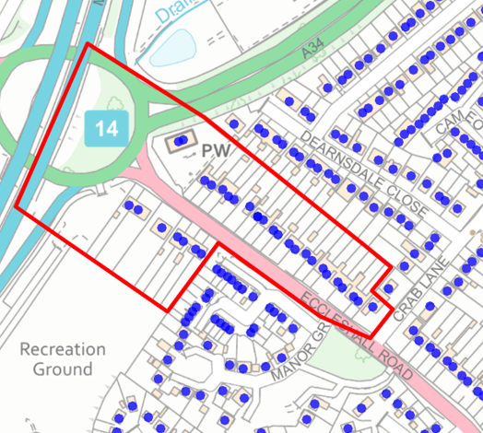
31 addresses east of M6 J14.
- With Stan Robbinson being invited to meet with the highways team to discuss the impacts of the diversions on their business. Can this invite also be extended to other businesses in the area that will be impacted?
Cllr Pert stated that he would be willing to offer a meeting with Stan Robinson Haulage. However, this would need to be discussed and agreed by SCC, as all relevant information has already been shared and responses to the questions raised have been provided.

- Severn Trent Water have previously told residents in Creswell that a new water mains pipe is needed to improve the water pressure issues they have been facing since the Marston Grange development. Have STW been specifically consulted on this work for that matter? E.g. residents don’t want this work to complete, then for STW to dig up the street again to install the new pipe.
The S278 works include the requirement to abandon an existing and install a replacement water main on the southern side of Creswell Grove. This has been identified by STW as necessary to facilitate the proposed widening of Creswell Grove. SCC Traffic and Network has confirmed that there are currently no planned permits from STW, nor any forward planning notices indicating that additional works are required within this area.

- Will ambulances and other emergency services be able to travel against the one way system? My understanding is that they shouldn’t, but that it will not be enforced for emergency vehicles. Can this be confirmed.
The Principal Contractor will ensure that access for emergency vehicles is maintained. A system will be implemented to allow for the immediate stoppage of traffic to create a clear and passable route when required. Designated and appropriately briefed staff will be in place and ready to act to facilitate emergency access.

- Has an Equality Impact Report been produced for the TM plan?
SCC Traffic and Network has confirmed that it is not aware of an Equality Impact Report request, and this is not something specifically required. The Highways Act 1980, the New Roads and Street Works Act 1991, the Traffic Management Act 2004, and the Code of Practice for the Safety at Street Works and Road Works collectively require all parties to consider the needs of all road users, including pedestrians and cyclists, when planning and undertaking works.

- For residents living at 6-20 Creswell Grove who have children at Cooper Perry’s. Is there any options to allow for them to have access to frontages against the flow of the one way, rather than having to follow a diversion.
The Principal Contractor has confirmed that it is not possible to safely accommodate members of the public travelling against the flow of traffic through the works area.

- Residents have highlighted that there is a parcel of land by 391 Eccleshall road, they were interested to know the owners of this land, and whether this could be used by residents to park and walk to their properties rather than using the diversion routes. Can any info be provide on this. Photo below for reference.

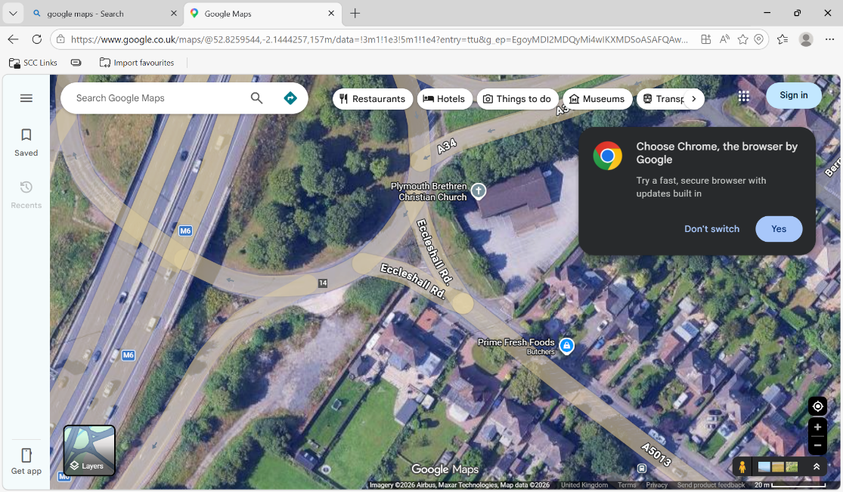

Highway mapping shows that the land is not adopted Highway Maintenance at Public Expense (HMPE) by SCC.

